Date:01-10-2026
Program 1
Code:
#include <stdio.h>
#include <string.h>

int main() {
int n, i, j, len, palindrome;
char words[100][100];

printf("Enter number of words: ");
scanf("%d", &n);

printf("Enter the words:\n");
for (i = 0; i < n; i++) {
scanf("%s", words[i]);
}

for (i = 0; i < n; i++) {
len = strlen(words[i]);
palindrome = 1;

for (j = 0; j < len / 2; j++) {
if (words[i][j] != words[i][len - j - 1]) {
palindrome = 0;
break;
}
}
if (palindrome) {
printf("First palindromic string: %s", words[i]);
return 0;
}
}

printf("No palindromic string found");

return 0;
}
Output:
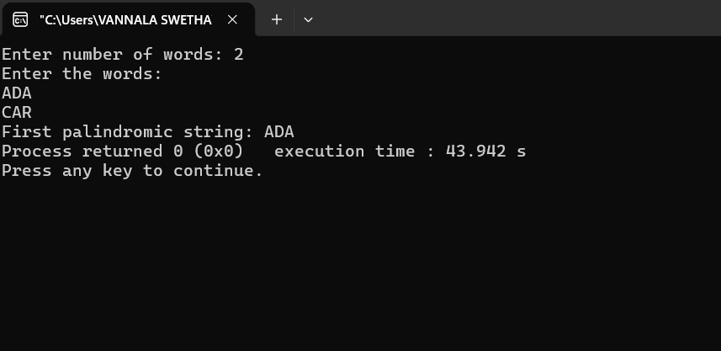

Program 2:
Code:
#include <stdio.h>

int main() {
int n, m, i, j;
int answer1 = 0, answer2 = 0;

printf("Enter size of nums1: ");
scanf("%d", &n);

int nums1[n];

printf("Enter nums1 elements: ");
for (i = 0; i < n; i++) {
scanf("%d", &nums1[i]);
}

printf("Enter size of nums2: ");
scanf("%d", &m);

int nums2[m];

printf("Enter nums2 elements: ");
for (i = 0; i < m; i++) {
scanf("%d", &nums2[i]);
}

for (i = 0; i < n; i++) {
for (j = 0; j < m; j++) {
if (nums1[i] == nums2[j]) {
answer1++;
break;
}
}
}

for (i = 0; i < m; i++) {
for (j = 0; j < n; j++) {
if (nums2[i] == nums1[j]) {
answer2++;
break;
}
}
}

printf("Answer = [%d, %d]", answer1, answer2);

return 0;
}

Output: 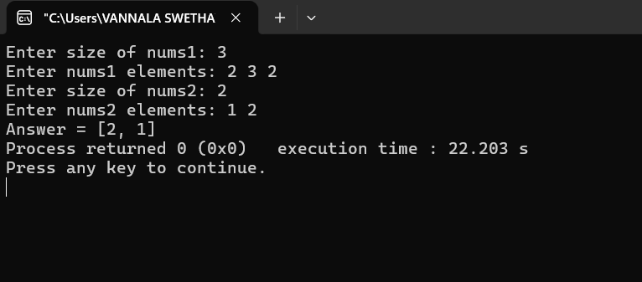

Program 3:
Code:
#include <stdio.h>

int main() {
int n, i, j, k;
int total = 0;
int count, found;

printf("Enter size of array: ");
scanf("%d", &n);

int nums[n];

printf("Enter elements: ");
for (i = 0; i < n; i++) {
scanf("%d", &nums[i]);
}

for (i = 0; i < n; i++) {
count = 0;

for (j = i; j < n; j++) {
found = 0;

for (k = i; k < j; k++) {
if (nums[k] == nums[j]) {
found = 1;
break;
}
}

if (found == 0) {
count++;
}

total = total + count * count;
}
}

printf("Answer = %d", total);

return 0;
}
Output:
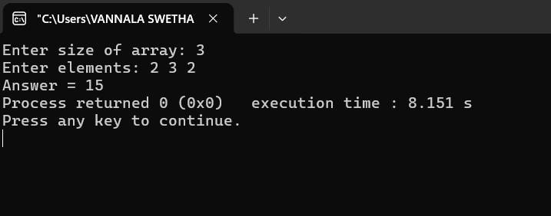

Program 4:
Code:
#include <stdio.h>

int main() {
int n, k, i, j;
int count = 0;

printf("Enter size of array: ");
scanf("%d", &n);

int nums[n];

printf("Enter elements: ");
for (i = 0; i < n; i++) {
scanf("%d", &nums[i]);
}

printf("Enter k: ");
scanf("%d", &k);

for (i = 0; i < n; i++) {
for (j = i + 1; j < n; j++) {
if (nums[i] == nums[j] && (i * j) % k == 0) {
count++;
}
}
}

printf("Number of valid pairs = %d", count);

return 0;
}
Output: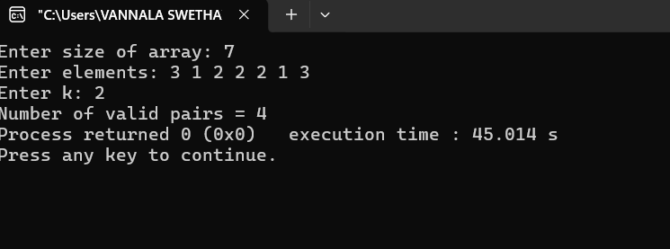

Program 5:
Code:
#include <stdio.h>

int main() {
int n, i, j;
int unique = 0;
int found;

printf("Enter size of array: ");
scanf("%d", &n);

int nums[n];

printf("Enter elements: ");
for (i = 0; i < n; i++) {
scanf("%d", &nums[i]);
}

for (i = 0; i < n; i++) {
found = 0;

for (j = 0; j < i; j++) {
if (nums[i] == nums[j]) {
found = 1;
break;
}
}

if (found == 0) {
unique++;
}
}

printf("Number of unique elements = %d", unique);

return 0;
}

Output:
